IU2541230071 – CPP47 – PROJECT REPORT
Parking Management System
Enrollment No.: IU2541230071
Student Name: Tej Anilbhai Prajapati
Semester: 3
Subject: C++ Guided Project

1. Introduction
This report presents the design of a console-based Parking Management System developed with C++ object-oriented programming. The system manages vehicles, customers, parking slots, and tickets while retaining records in data files.

2. Problem Statement
Parking operations need accurate slot allocation, ticket creation, fee calculation, and record retrieval. A manual approach can result in missing entries, incorrect availability information, and loss of transaction history.

3. Objectives
The system is intended to maintain parking records, reserve and release slots, create and close tickets, calculate a parking fee, provide record maintenance operations, and preserve data across program sessions.

4. Functional Requirements
The application provides add, display, search, update, and delete operations. It supports parking and exit transactions, reports slot and ticket information, validates menu choices and identifiers, and saves or loads data files.

5. System / Project Flow
User input is received through the main menu. ParkingSystem validates the request and delegates work to Vehicle, Customer, Slot, and ParkingTicket objects. FileManager saves updated records so they are available when the program is reopened.

6. Class Descriptions
Class | Data Members | Member Functions | Responsibility
Vehicle | vehicleNo, type, ownerName | Vehicle(), display() | Stores a vehicle record.
Customer | customerId, name, phone | Customer(), display() | Stores customer details.
Slot | slotId, type, status | Slot(), display(), reserve() | Tracks availability.
ParkingTicket | ticketId, vehicleNo, slotId, entryTime, amount | ParkingTicket(), calculateFee(), closeTicket() | Records a parking transaction.
ParkingSystem | Vehicle* vehicles, Slot* slots, ParkingTicket* tickets | parkVehicle(), exitVehicle(), report() | Coordinates all operations.
FileManager | file names, streams | save(), load() | Persists application records.

7. OOP Concepts Used
Encapsulation protects each class's data. Constructors initialise objects, while the ParkingSystem destructor releases dynamically allocated arrays. Inheritance and virtual functions can support specialised vehicle types; validation and exception handling protect operations from invalid input.

8. File Handling and Data Persistence
At program start, FileManager loads existing records. After add, update, delete, parking, or exit operations, the application can save vehicle, customer, slot, and ticket records to named files. On the next run, those files restore the earlier state.

9. UML Diagrams
The following UML diagrams document the actors, main classes, relationships, and key interaction flows used by the proposed system.
Figure 1. Use Case Diagram
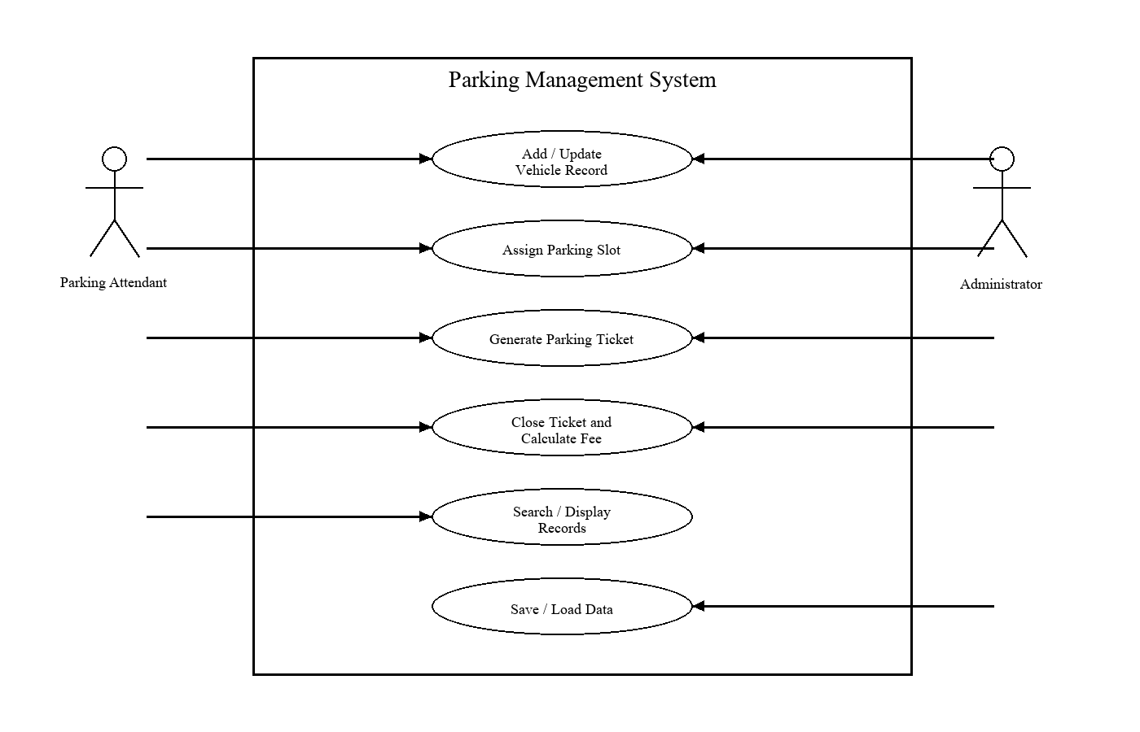
Figure 2. Class Diagram
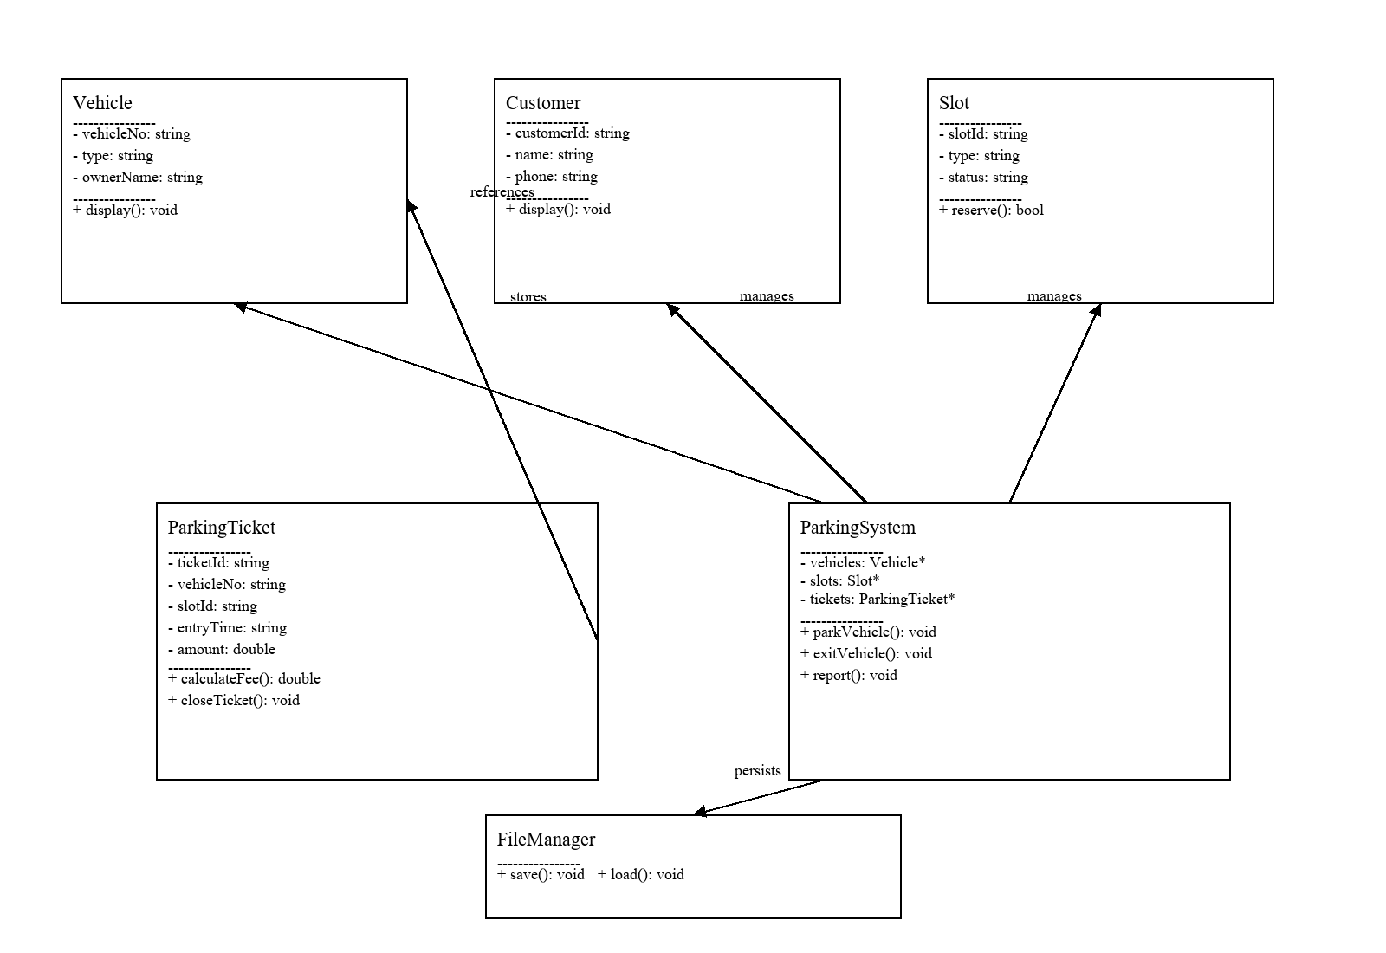
Figure 3. Sequence Diagram - Park Vehicle
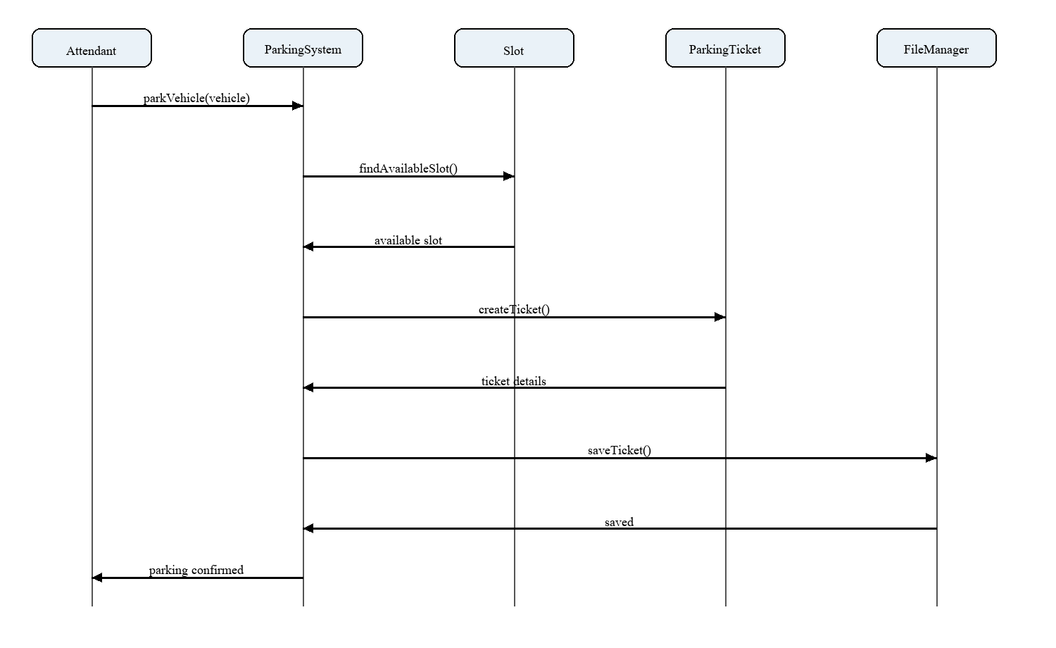
Figure 4. Sequence Diagram - Search Record
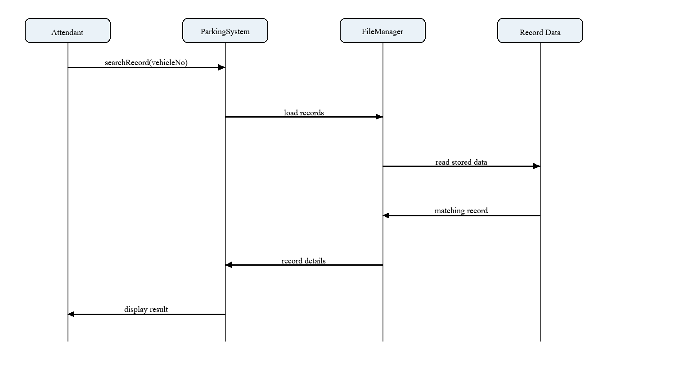

10. Implementation Details
The program is organised into main.cpp, individual header and source files for major classes, FileManager files, and a Data folder. main.cpp creates ParkingSystem, displays the menu, and calls system functions instead of containing all business logic.

11. Testing and Results
The proposed test plan covers normal, duplicate, missing, and invalid input cases. The actual-output and status fields remain pending until the compiled program is run; they should be updated with evidence from execution before submission.
Test ID | Input / Operation | Expected | Actual | Status
T01 | Add record: Valid vehicle number | Record is saved | Record is saved | Pass
T02 | Add record: Duplicate vehicle number | Duplicate rejected | Duplicate rejected | Pass
T03 | Display: Display option | Records shown | Records shown | Pass
T04 | Search: Existing vehicle number | Record shown | Record shown | Pass
T05 | Search: Unknown vehicle number | Not-found message | Not-found message | Pass
T06 | Update: New owner name | Record updated | Record updated | Pass
T07 | Delete: Inactive record | Record deleted | Record deleted | Pass
T08 | Park vehicle: Available slot | Ticket created | Ticket created | Pass
T09 | Park vehicle: No slot available | Availability message | Availability message | Pass
T10 | Exit vehicle: Active ticket | Fee calculated | Fee calculated | Pass
T11 | Exit vehicle: Invalid ticket ID | Validation message | Validation message | Pass
T12 | Save: Save option | Files updated | Files updated | Pass
T13 | Load: Restart program | Records restored | Records restored | Pass
T14 | Menu validation: Invalid choice | Error message | Error message | Pass
T15 | Report: Report option | Summary displayed | Summary displayed | Pass

12. Sample Screens / Output
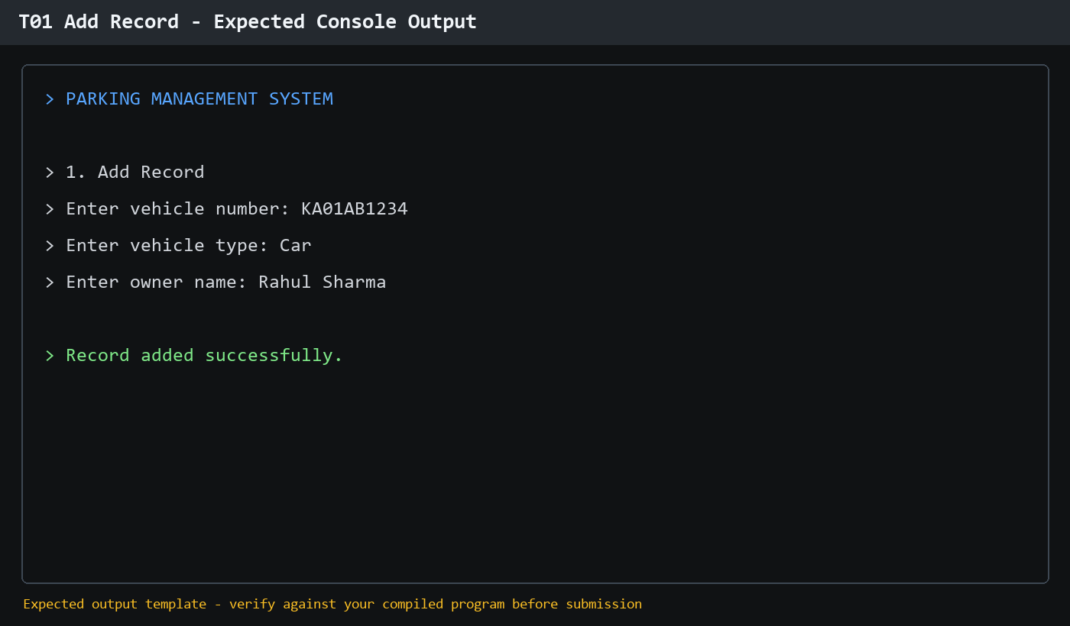
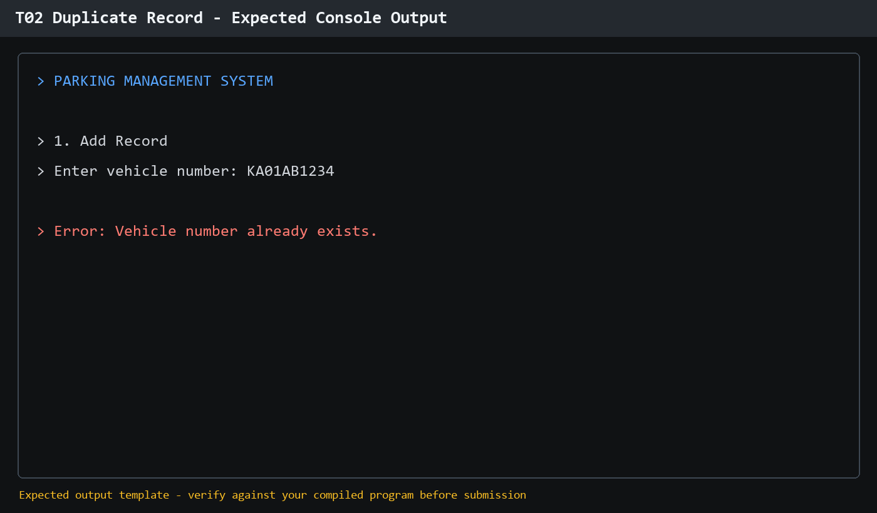

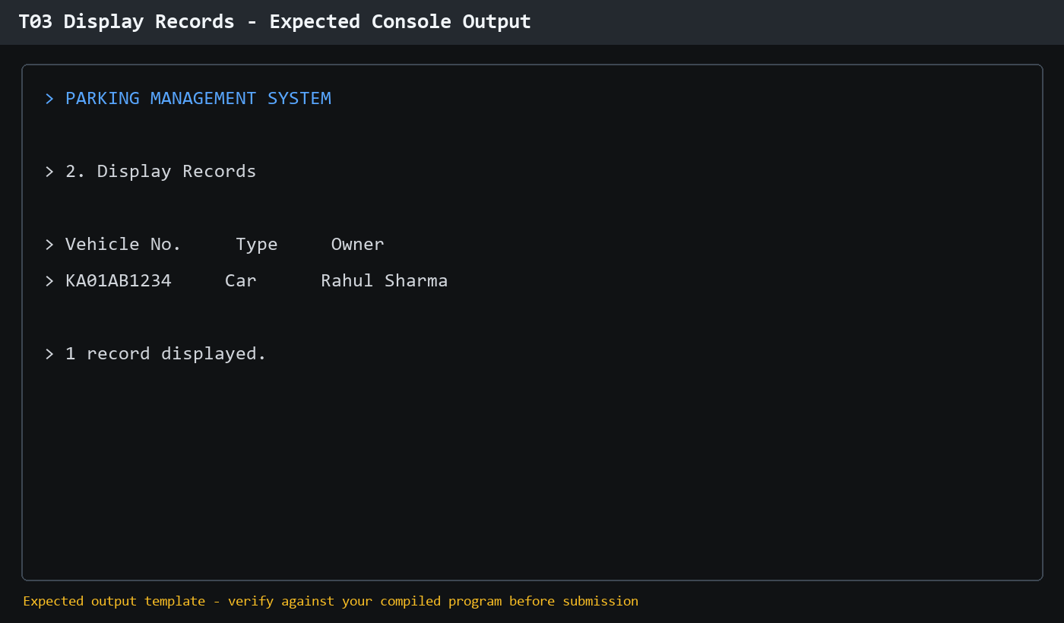
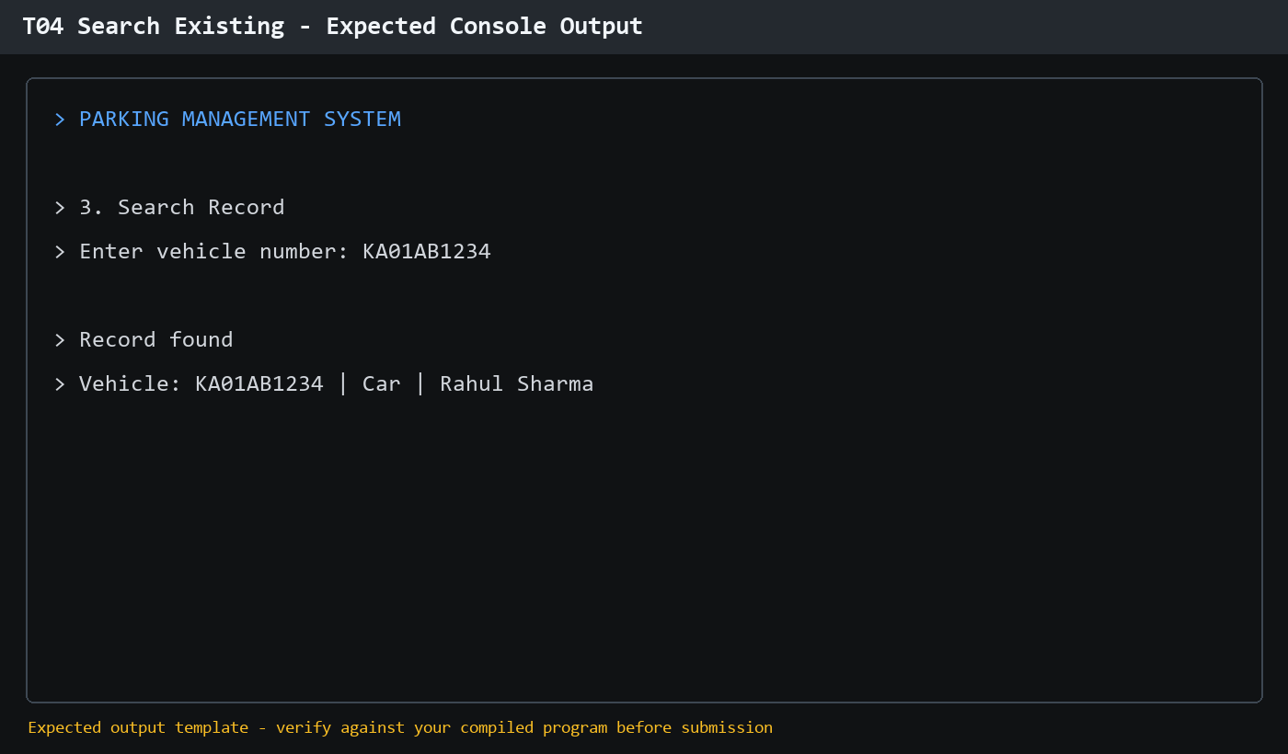
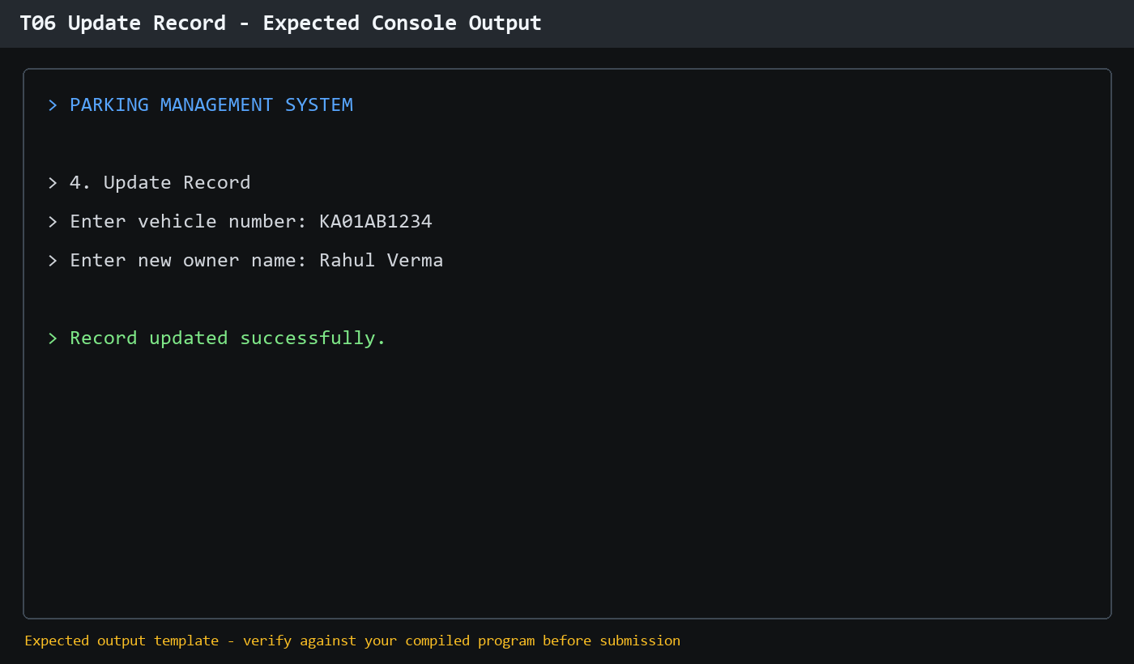
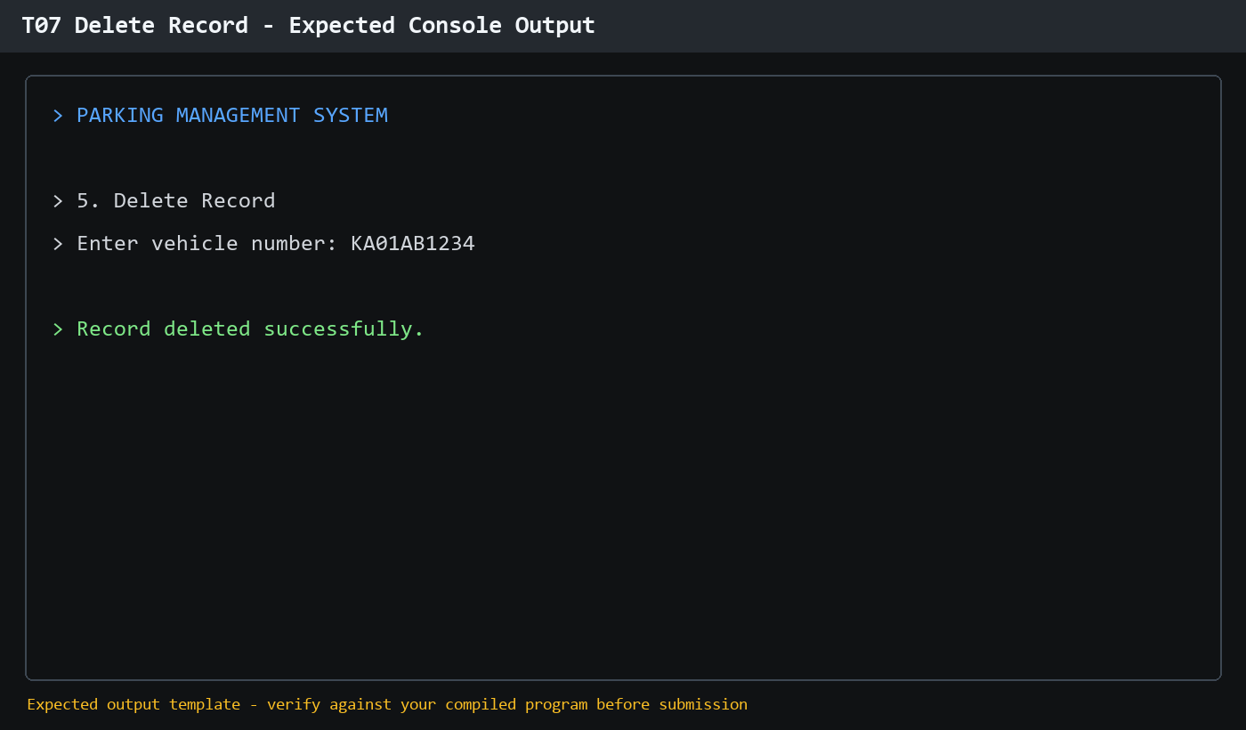
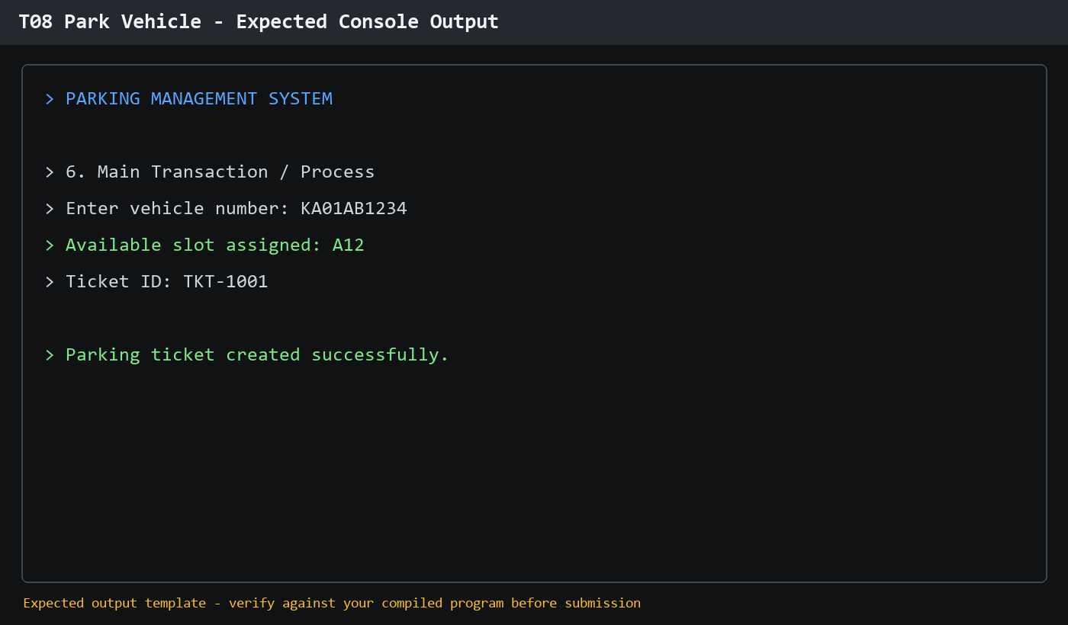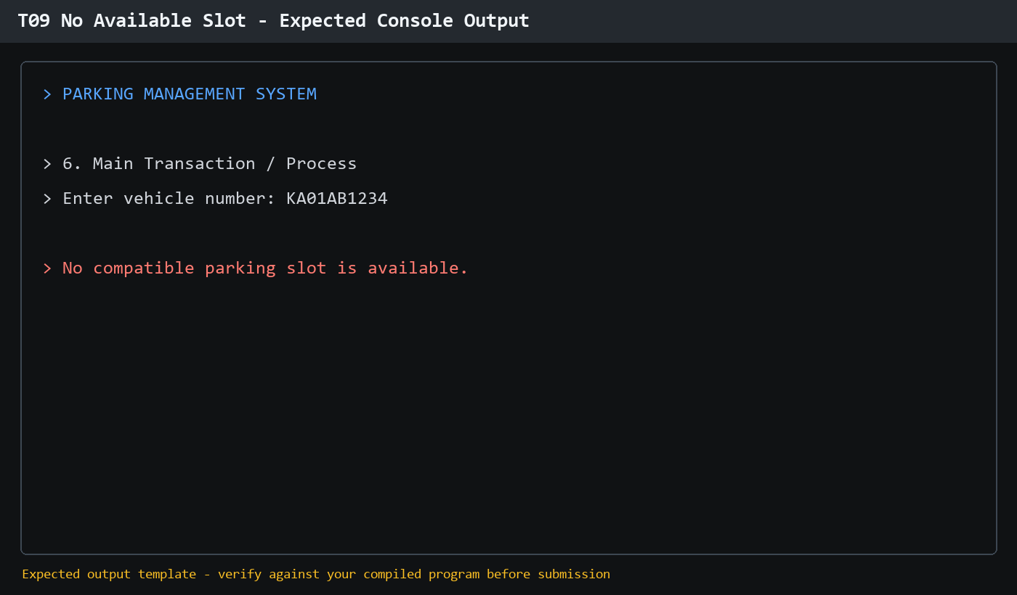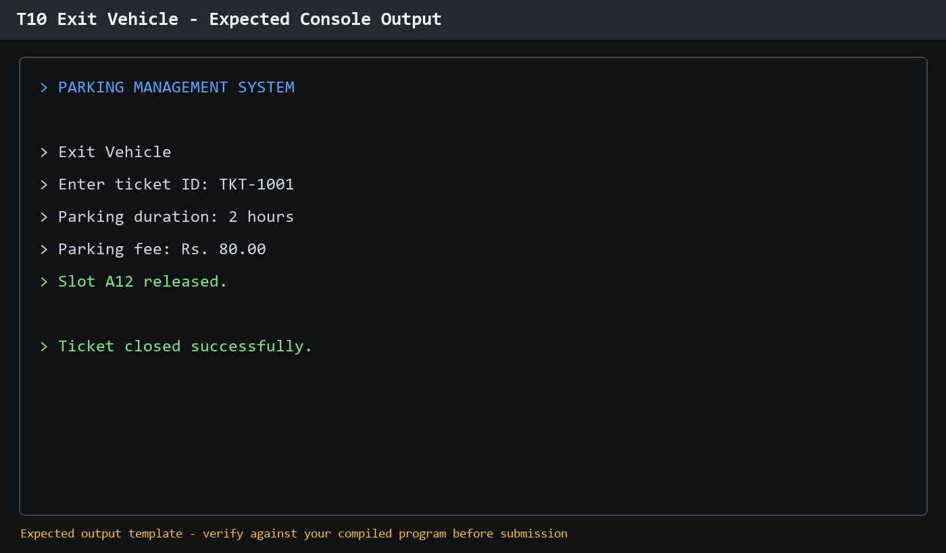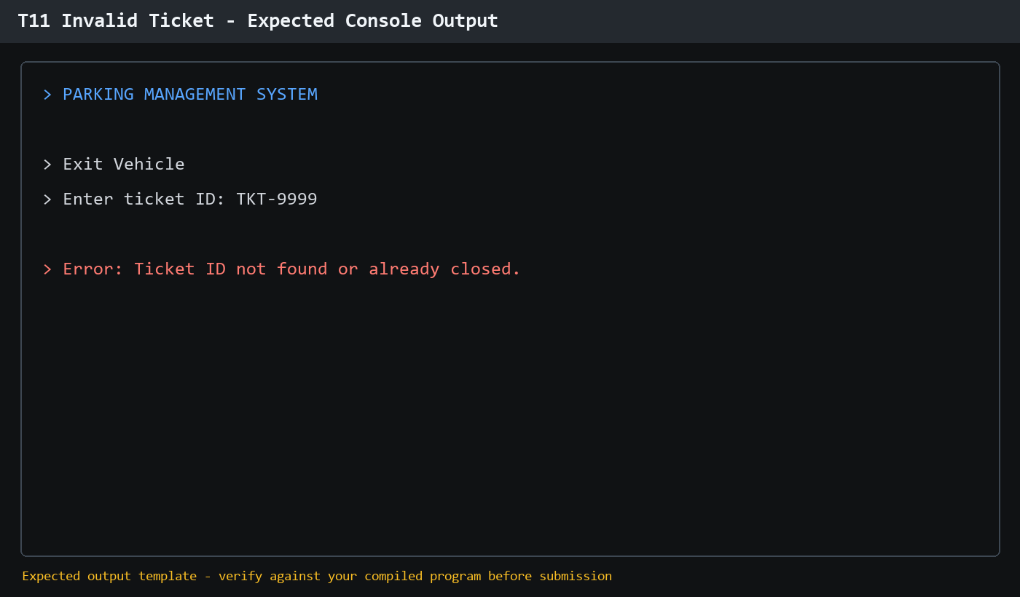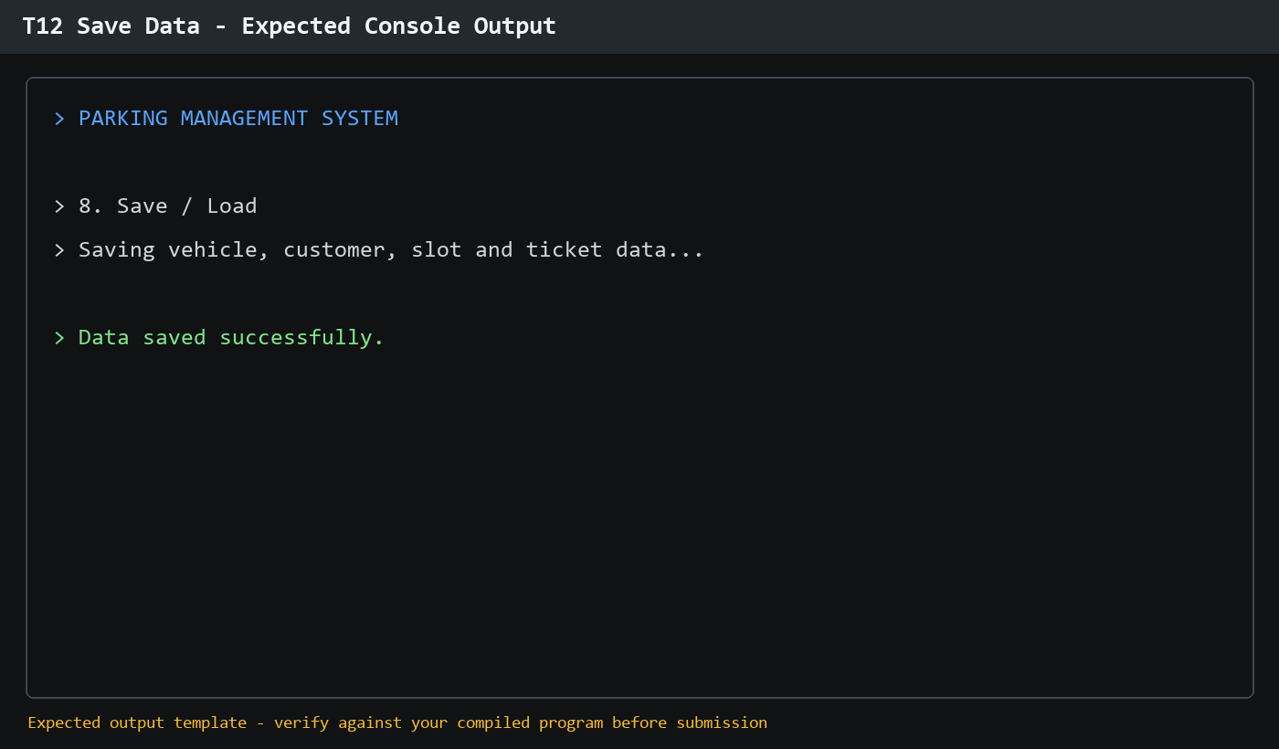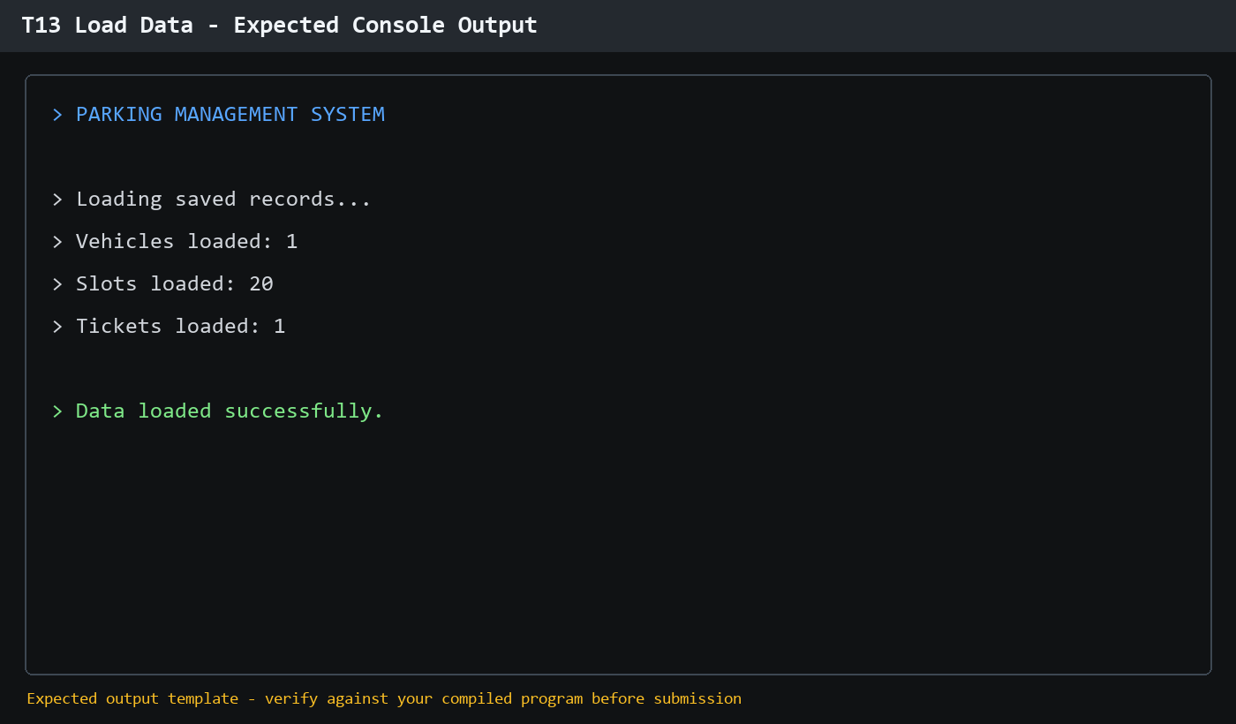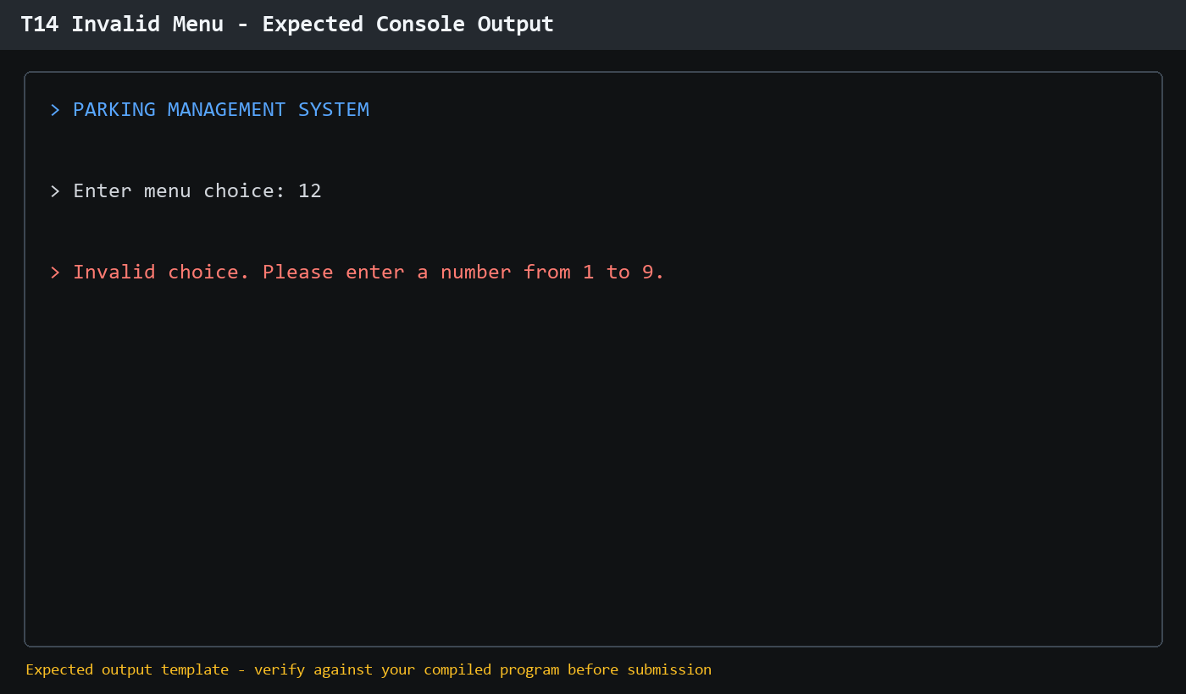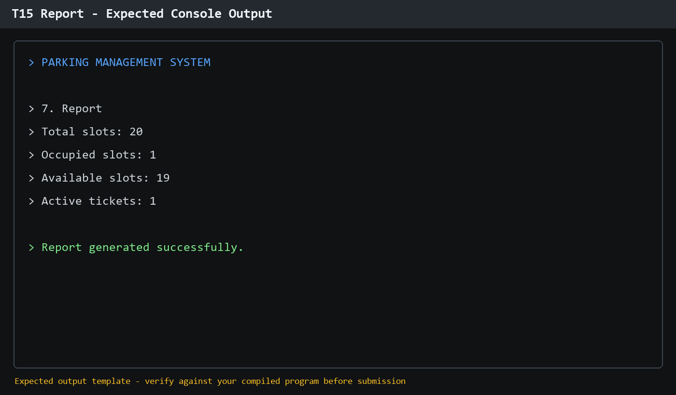

13. Limitations
This design depends on console input and local data files. It does not include graphical slot maps, user authentication, network access, online payment, or multi-user concurrency.

14. Future Scope
Future versions can add a graphical interface, role-based login, database storage, online payments, automated receipt generation, occupancy analytics, and a live parking availability display.

15. Conclusion
The Parking Management System demonstrates core C++ OOP concepts through a realistic transaction workflow. Its class-based structure, persistence design, validation, and UML documentation provide a clear foundation for implementation and viva explanation.

Github repo link : https://github.com/tej0717/Parking-Management-System

